PROJECT FINAL REPORT

1.INTRODUCTION:
1.1 Project Overview
The India's Agricultural Cultivation Analysis Using Tableau project focuses on analyzing historical agricultural data from 1997 to 2021 using interactive data visualizations. The project transforms raw agricultural data into meaningful dashboards and stories that provide insights into crop production, cultivated area, seasonal variations, and state-wise performance. Using Tableau, users can explore the data through interactive filters, charts, maps, and KPI cards. The solution supports farmers, government policy analysts, and agribusiness investors by enabling data-driven decision-making, improving agricultural planning, and identifying production trends across India.
1.2 Purpose:
The purpose of this project is to analyze India's agricultural cultivation data using Tableau and transform it into interactive dashboards and stories. The project helps users understand crop production trends, seasonal variations, and state-wise performance through visual analytics. It enables farmers, government policy analysts, and agribusiness investors to make informed, data-driven decisions for better agricultural planning and resource management.

2.IDEATION PHASE:
2.1 Problem Statement:
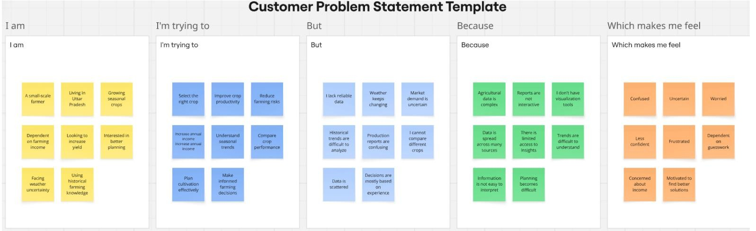
2.2 Empathy Map Canvas:
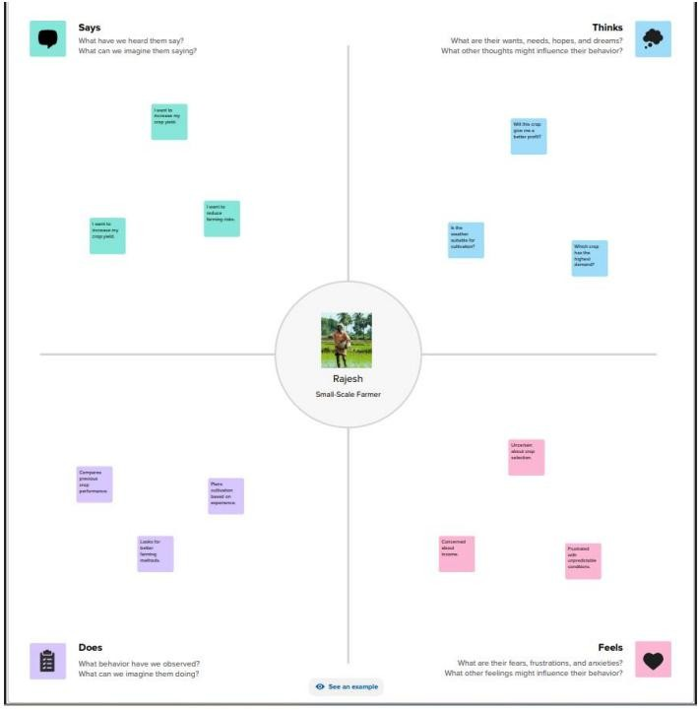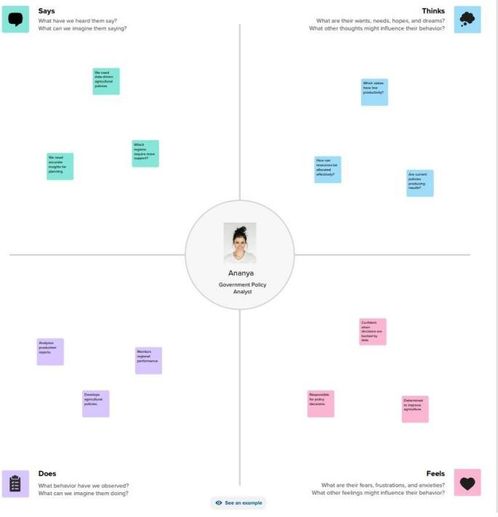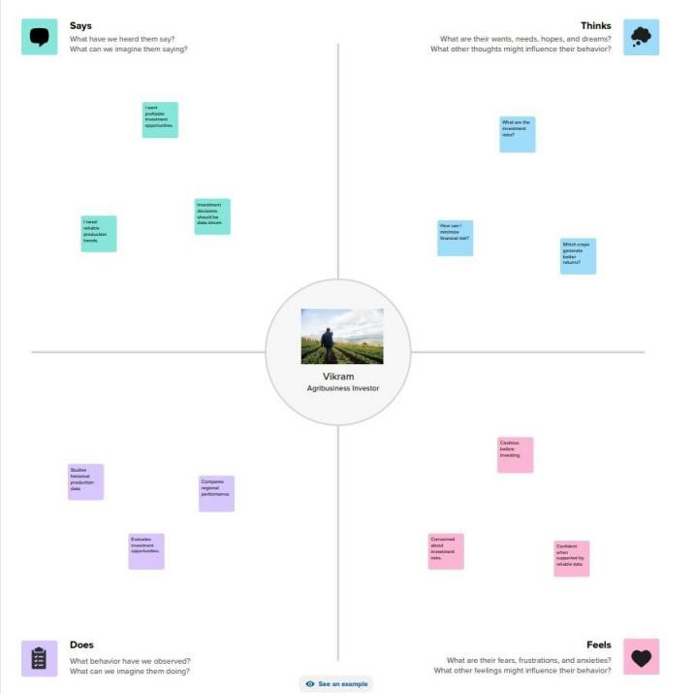

2.3 Brain Storming:
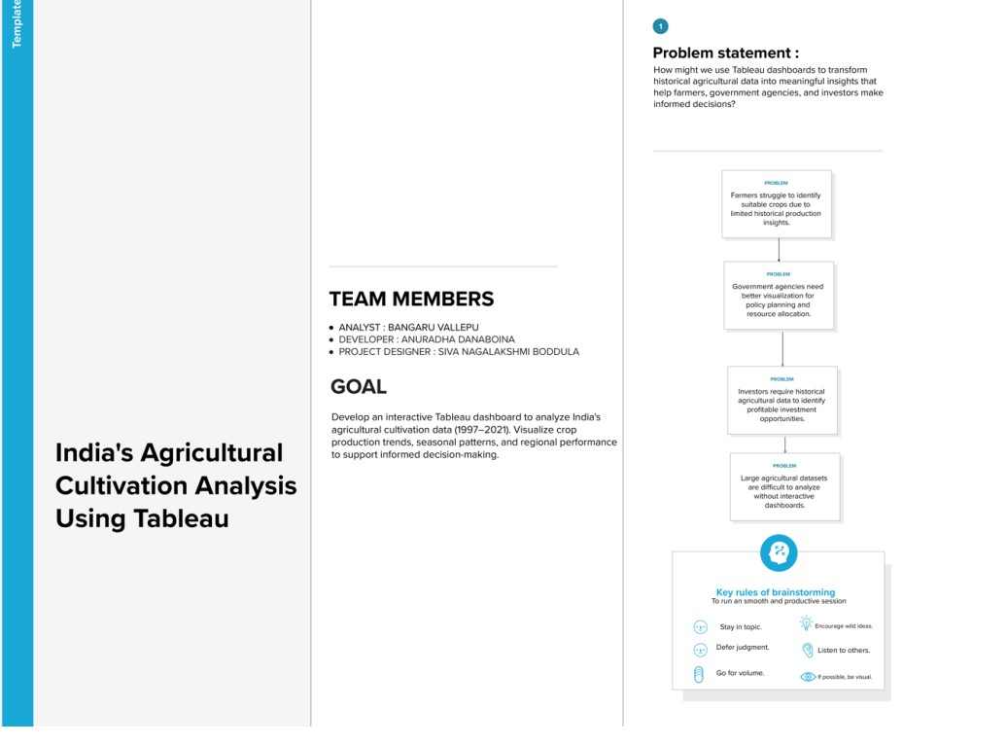

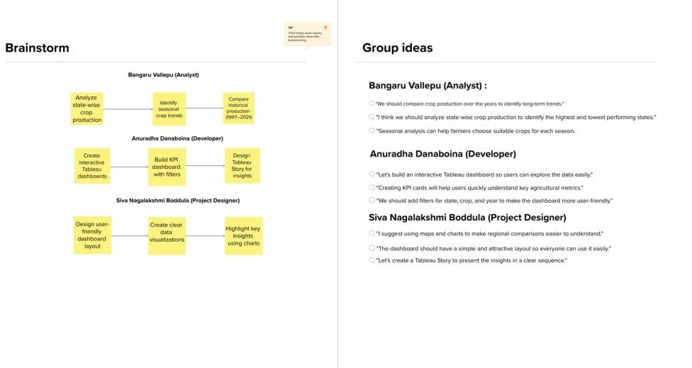

3.REQUIREMENT ANALYSIS:
3.1 Customer Jornery Map:
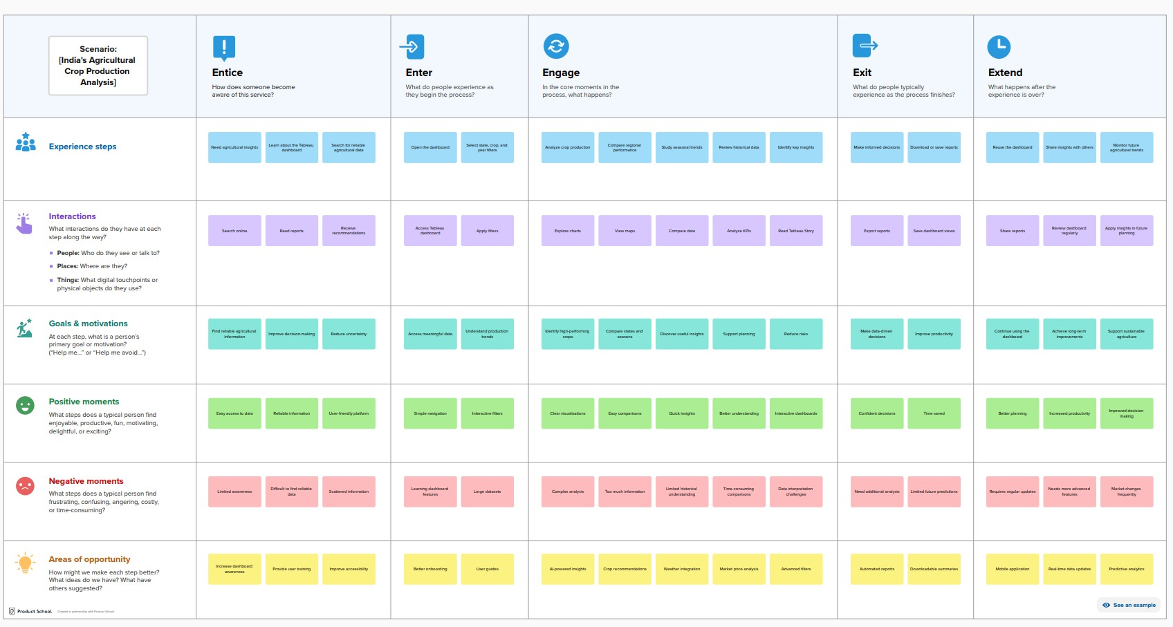
3.2 Solution Requirement:
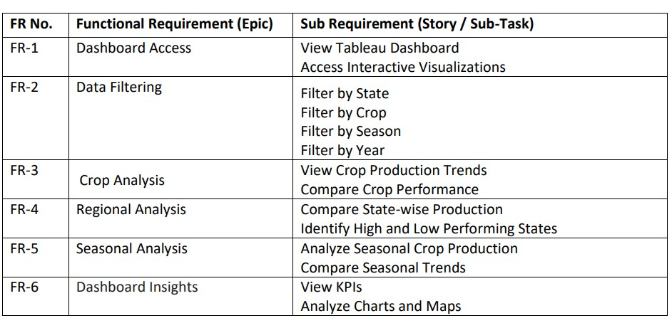
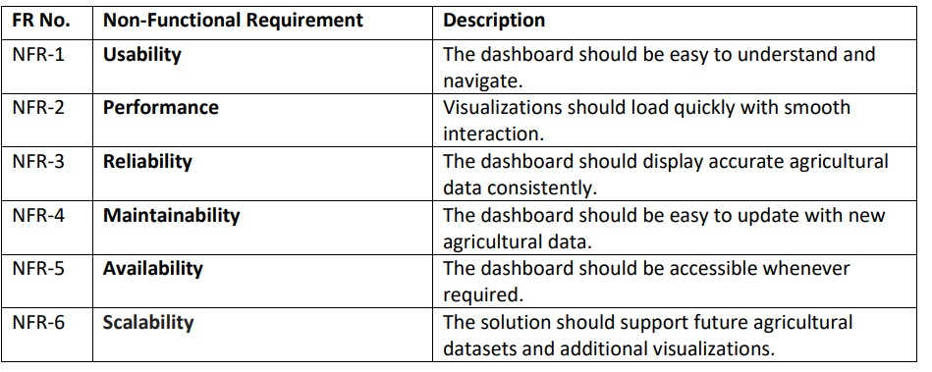
3.3 Data Flow Diagram:

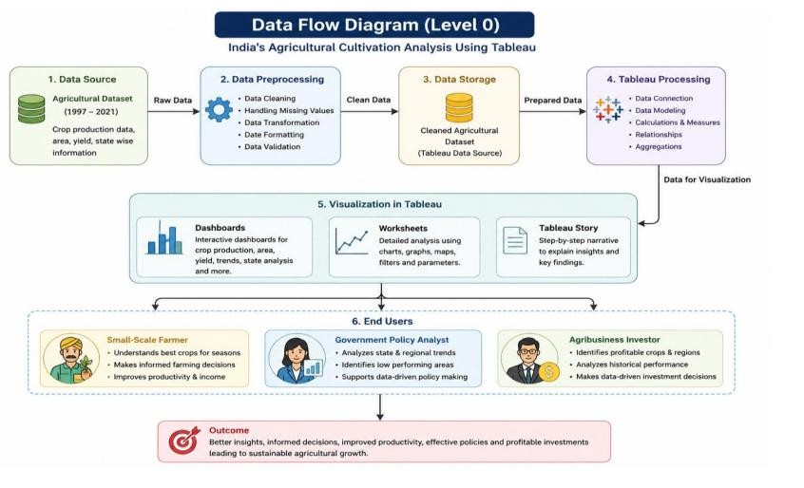

3.3 Technology Stack:
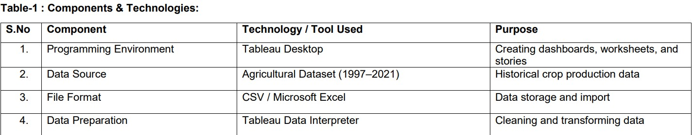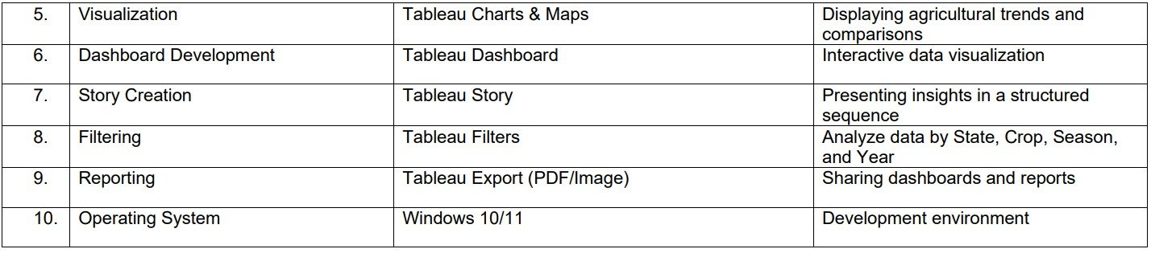

4.PROJECT DESIGN:
4.1 Problem Solution Fit:
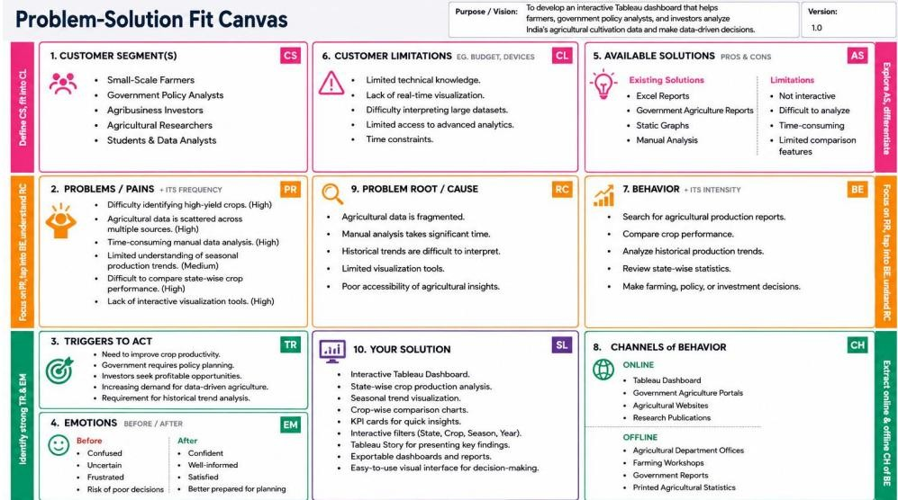

4.2 Proposed Solution:
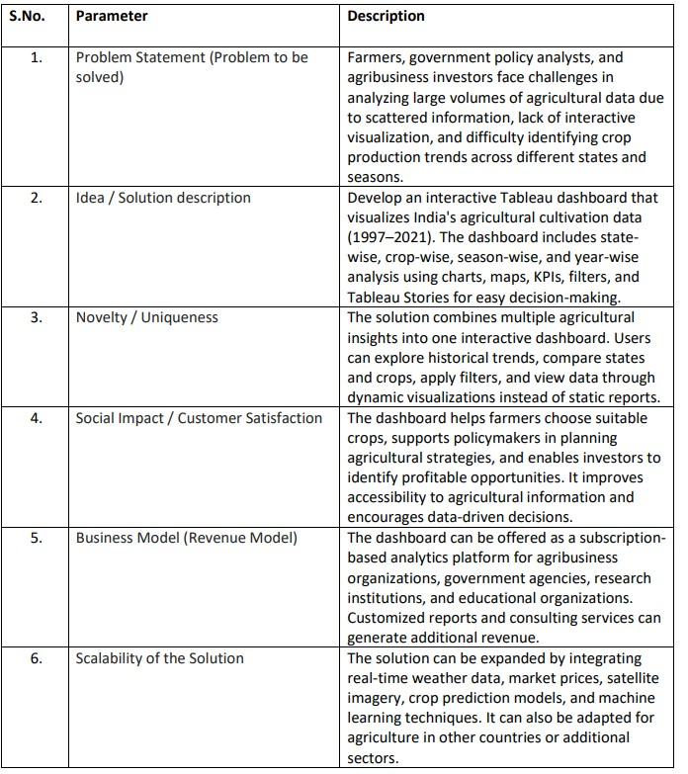

4.3 Solution Architecture:
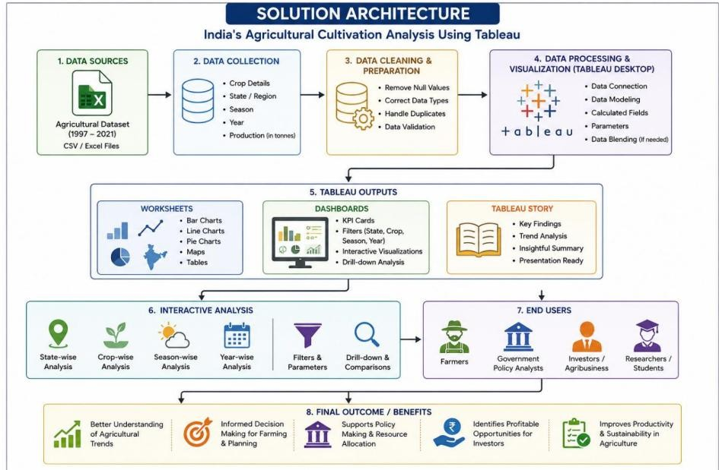
5.PROJECT PLANNING & SCHEDULING:
5.1 Project Planning:
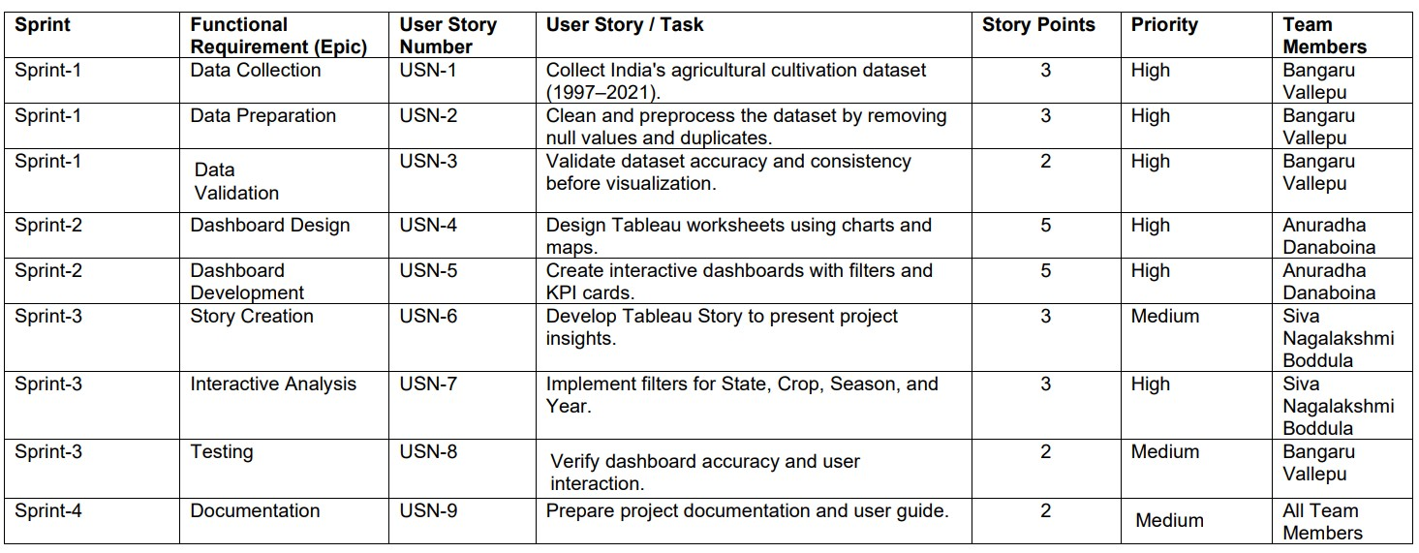
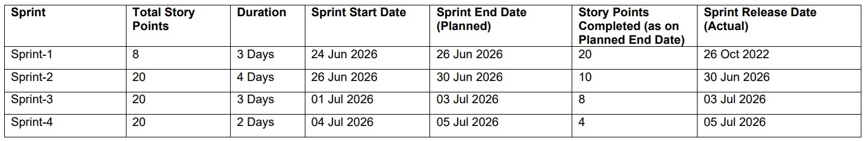
6.FUNCTIONAL & PERFORMANCE TESTING:
6.1 Project Planning:
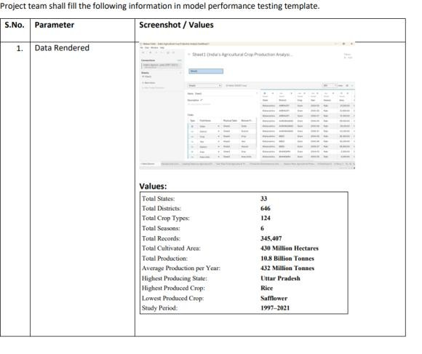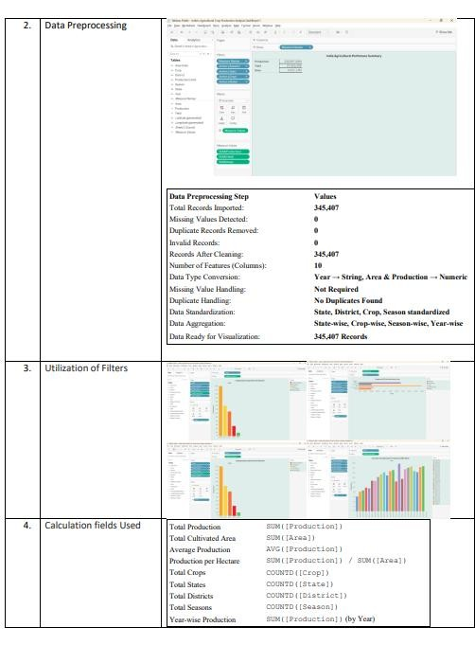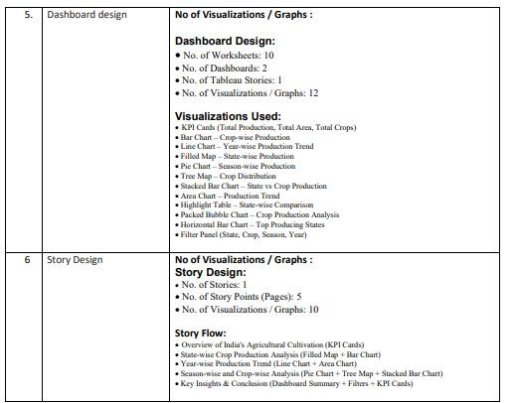

7.RESULTS:
7.1 Output Screen Shots:
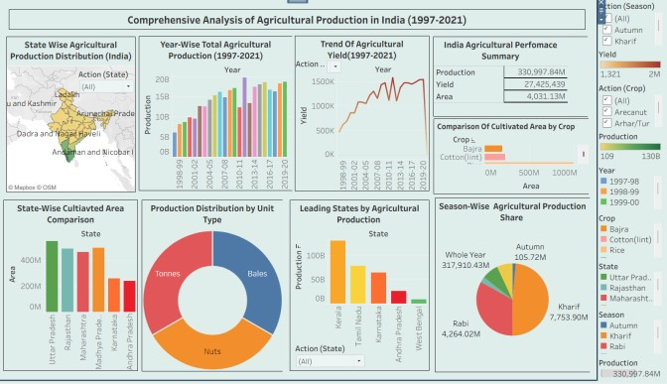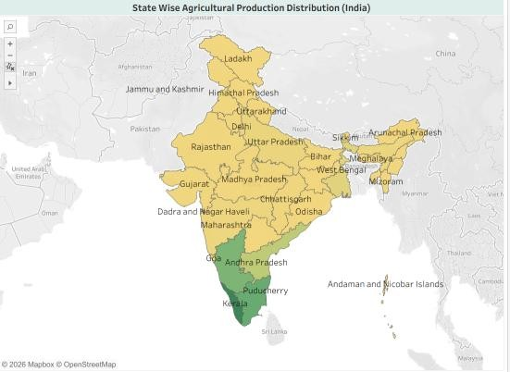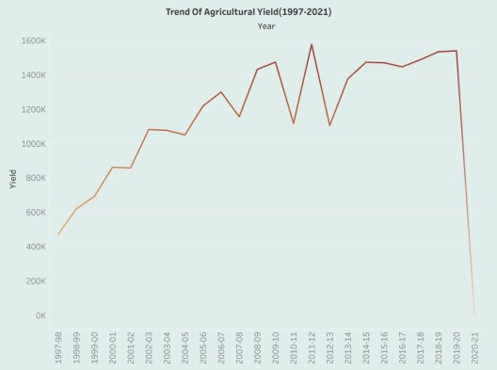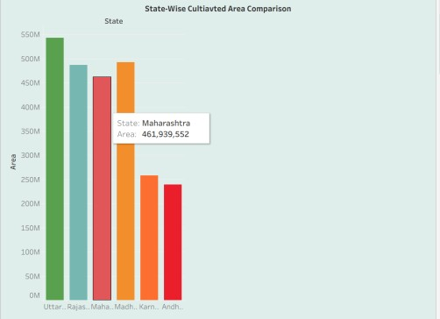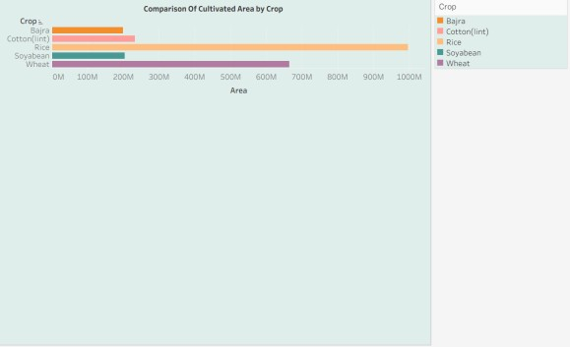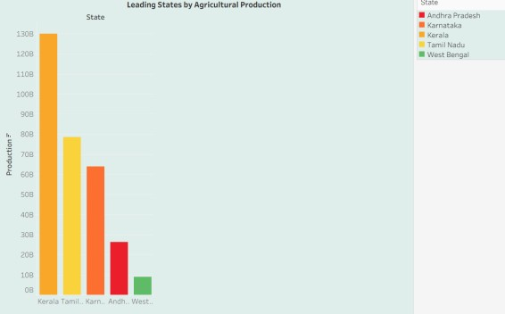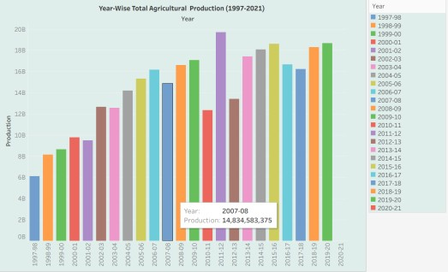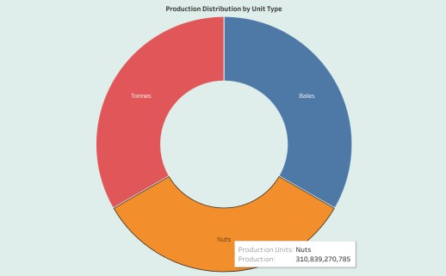

8.ADVANTAGES & DISADVANTAGES:
Advantages:
- Enables state-wise, crop-wise, season-wise, and year-wise analysis.
- Supports data-driven decision-making for farmers, policymakers, and investors.
- Helps identify agricultural production trends and regional performance.
- Interactive filters allow users to customize and explore the data efficiently.
- Reduces the time required for manual data analysis.
- Improves understanding through dashboards, maps, charts, and Tableau Stories.
- Generates meaningful insights that support better agricultural planning and resource allocation. Disadvantages:
- The analysis depends on the accuracy and completeness of the available dataset.
- The project uses historical data and does not provide real-time agricultural information.
- Tableau dashboards require periodic updates when new data becomes available.
- The dashboard cannot predict future crop production without predictive analytics or machine learning.
- Users with limited Tableau knowledge may require basic training to use advanced features.
- Internet access may be required when dashboards are published online.
- The project does not consider external factors such as weather conditions, market prices, or government policies unless additional datasets are integrated.
9.CONCLUSION:
The India's Agricultural Cultivation Analysis Using Tableau project successfully transformed historical agricultural data (1997–2021) into interactive dashboards and stories that provide meaningful insights into crop production, cultivated area, seasonal variations, and state-wise agricultural performance. By using Tableau's visualization capabilities, the project simplifies complex datasets into clear and easy-to-understand charts, maps, and KPI dashboards.
The developed solution enables farmers, government policy analysts, and agribusiness investors to analyze agricultural trends, compare regional performance, and make informed, data-driven decisions. Overall, the project demonstrates how data visualization can improve agricultural planning, support effective policy formulation, and promote better investment decisions, contributing to a more efficient and sustainable agricultural sector.

- FUTURE SCOPE:
The India's Agricultural Cultivation Analysis Using Tableau project can be enhanced in several ways to provide more advanced insights and decision support. Future improvements include:
  - Integrate real-time agricultural data for up-to-date analysis.
  - Include weather and climate data to study its impact on crop production.
  - Incorporate market price information to support better farming and investment decisions.
  - Apply Machine Learning and Predictive Analytics to forecast crop yields and production trends.
  - Develop a web or mobile application for easier access to dashboards.
  - Expand the analysis by including soil quality, irrigation, and fertilizer usage data.
  - Enable automatic data updates through cloud-based data integration.
  - Add AI-based recommendations for crop selection and resource planning.
  - Extend the project to analyze agricultural data from other countries for comparative studies.
  - Improve dashboard interactivity with advanced filters, alerts, and customized reports.
These enhancements would make the system more intelligent, scalable, and valuable for farmers, policymakers, researchers, and agribusiness investors.
- APPENDIX:
GITHUB REPOSITORY LINK: https://github.com/ShaikMahee756/india-s-Agricultural-Crop-Production-Analysis.git
Data Set Link: India’s Agricultural Crop Production Analysis(1997-2021).xlsx

THANK YOU

